Artwork by Chelsea Crosby, Living Water, Edited by Verity Murray, St. Nicholas
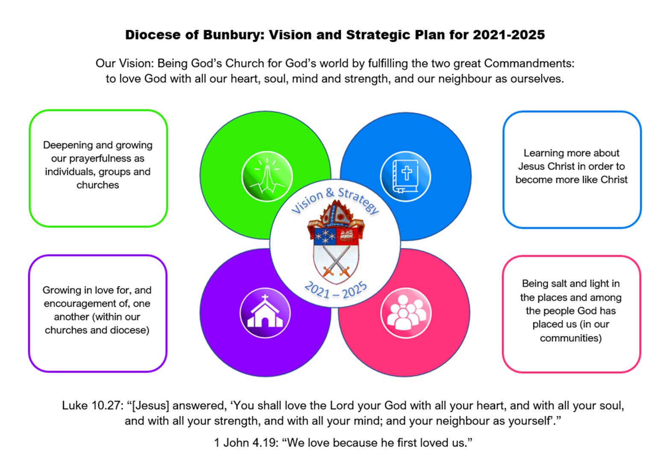

Love One Another

Introduction
This is a 6-week course for Lent 2024 designed for groups or individuals to reflect on our current diocesan strategy of ‘Growing in Love and Encouragement for One Another.’
The theme of love is arguably one of the most significant in the entire Bible, and a defining part of what it means to be a Christian. The content looks at the biblical basis for why we are called, and indeed commanded, to love one another, including the nature of the triune God we worship, and what it means to be created as human beings in this image. The course looks at the many New Testament passages that refer to love between the members of the church, including Christians being addressed as ‘beloved’. The New Testament goes further than this for it also defines what love is, and the significance of love towards others as both an attitude and one that leads to loving action. Each week will link to the next so it is hoped that groups and individuals will be able to follow the whole Lent course, or catch up individually. There are questions for you to consider and ponder, whether you are working through this on your own, or within a group. I would like to thank Verity Murray for editing these notes and Chelsea Crosby for her beautiful cover design.

Programme
Week 1 - What has love got to do with it? (14-20 Feb)
Week 2 - Understanding love – starting with God. (21-27 Feb)
Week 3 - Commanded to love? The emphasis of the Old and New Testaments
(28 Feb – 5 March)
Week 4 - Becoming a new community
(6 – 12 March)
Week 5 - Encouraging one another (13 – 19 March)
Week 6 - Love in action (20 – 26 March)

How to use this study
You will need a Bible (or a Bible app)
Thinking and talking about love can understandably raise all kinds of memories and emotions, sometimes quite unexpectedly and even unconsciously. Please therefore be kind and considerate to yourself (as well as to others, if in group). You may need some time and space to consider these memories and emotions, and you may wish to share them with someone you trust and/or offer them to God in prayer. Jesus promised that God hears and answers our prayers (Matthew 7.7-11).
Extra study material is included at the end of each study under the heading ‘For Further Reflection’. This section is entirely optional.

Week 1 – “What has love got to do with it?” (14-20 February)
Although the English language has been described as having more choices of words than any other language, at least two words appear to be exceptions. These are: ‘snow’ and ‘love’. In the case of snow, Icelandic language has 46 words for snow, Inuit 40-70 (depending on whether you live in Greenland or Alaska), and apparently there are 175-180 words for snow in Saami (spoken by those who live in Northern Scandinavia or Russia). When it comes to love, C.S. Lewis wrote a book on the 4 Greek words for ‘love’, but in English we mainly use just one word, love, which covers a wide range of meanings.
- Do you speak other languages? What words are used for ‘love’ in those languages?
- Are there other words we use that convey some of the meaning of love, for example: compassion, comfort?
- Tina Turner’s hit song: ‘What has love got to do with it’ describes love as ‘a second-hand emotion’ or a sweet ‘old-fashioned notion’. How would you describe love, or rate its importance?
- When we talk about ‘love’ in a Christian context, what do you think is being described?

Read 1 John 4:7-21
This is a profound passage and it is worth spending some time reflecting on it, whether you are on your own or in a group. The following questions may assist you:
- Who are the brothers or sisters John is referring to, do you think?
- How does John define love?
- What are the effects of this kind of love on people and their relationships?

How prominent is the theme of love in the Church?
The passage from 1 John is only one of many such passages in the Bible. However, it is not a theme that is always studied in great depth in the church (See ‘For Further Reflection’ below).
- Have you heard/read podcasts, sermons or Christian books on the subject of love? What did you learn from them?
- Why do you think the theme of love is so prominent in the Bible?

Pray
Break into pairs. Take it in turns to pray the words of Paul’s prayer for each other.

Paul’s prayer for the Ephesian church:
‘For this reason, I bow my knees before the Father, from whom every family in heaven and earth takes its name. I pray that, according to the riches of his glory, he may grant that you may be strengthened in your inner being with power through his Spirit, and that Christ may dwell in your hearts by faith, as you are being rooted and grounded in love. I pray that you may have the power to comprehend, with all the saints, what is the breadth and length and height and depth, and to know the love of Christ that surpasses knowledge, so that you may be filled with all the fullness of God. Now to him who by the power at work within us is able to accomplish abundantly far more than we can ask or imagine, to him be glory in the church and in Christ Jesus to all generations, forever and ever. Amen.’
(Ephesians 3.14-21)

For Further Reflection
As we shall see, love is a big theme in the Bible – both in the Old and New Testaments - but, perhaps surprisingly, it has not always been such a prominent theme in Western theology and Christian teaching. Two of the major books written on the subject of love, for example, – C.S. Lewis’ The Four Loves and Anders Nygren’s Agape and Eros were published over 60 and 90 years ago, respectively. Werner Jeanrond claimed in 2010 that there had been a shortage of new theological investigation about love over the previous 40 years. He thought this was a strange omission when:
‘Love is at the centre of Christian faith. God loves this universe in which human love as a gift of God is able to transform lives. God’s love and human love are of primary importance for theological reflection.’
This theme of love, however, is definitely present in our liturgy and in hymns and songs. For instance, you will often hear as the introduction to the Confession:
‘Hear, O Israel, the Lord your God is one; you shall love the Lord your God with all your heart, and with all your soul, and with all your mind, and with all your strength.’ Jesus said: ‘This is the great and first commandment. And a second is like it: you shall love your neighbour as yourself.’
And at the end of each Holy Communion service, you will also hear these words:
‘Go in peace to love and serve the Lord’.
When we think about hymns and songs, Charles Wesley’s hymn: Love Divine, all loves excelling is just one of many on this subject. These are the words of the first verse:
Love divine, all loves excelling,
joy of heav'n to earth come down,
fix in us Thy humble dwelling;
all Thy faithful mercies crown!
Jesus, Thou art all compassion,
pure, unbounded love Thou art;
visit us with Thy salvation;
enter every trembling heart.

Can you think of other hymns or songs on the theme of love?
When I mentioned writing this Lent course and the absence of much recent literature on the subject, Canon Karen Cave remembered she had a book called Divine Love, written in 1985 by Selwyn Hughes. Selwyn was a Welsh charismatic minister who devoted himself to writing, including the daily Bible study notes: Every Day with Jesus. Peter and Jeannie Cornish, in our Cathedral congregation, used to work with him in the UK and knew him well.
Selwyn noticed the difference between the significance of the theme of love in the Bible in comparison even with some other important biblical themes, such as faith. He quotes Professor Henry Drummond whose sermon on 1 Corinthians 13 was entitled: ‘The Greatest Thing in the World’. As Professor Drummond observed, Paul lists three great qualities in 1 Corinthians 13 – faith, hope and love, but did not “hesitate from declaring love to be the champion among them”. Selwyn also noted that John was writing his epistles at a time when he was contending with Gnosticism (a movement claiming secret personal knowledge for its adherents) and consequently uses the word ‘knowledge’ 36 times, but love is mentioned even more, 43 times. Selwyn also quotes Peter who, like Paul and John, points to the underpinning significance of love:
‘… you must make every effort to support your faith with goodness, and goodness with knowledge, and knowledge with self-control, and self-control with endurance, and endurance with godliness, and godliness with mutual affection, and mutual affection with love. For if these things are yours and are increasing among you, they keep you from being ineffective and unfruitful in the knowledge of our Lord Jesus Christ.’ (2 Peter 1:5-7)
You will remember that our 2nd diocesan Strategy was Learning more about Jesus Christ in order to become more like Christ. In this passage above, Peter claims love is at the root of faith and all these other qualities in comprehending more about Jesus Christ.

Agape: unconditional, selfless, and divine love - Eros: passionate, romantic, and sexual love - Philia: affectionate, friendly, and brotherly love - Storge: natural, familial, and protective love

